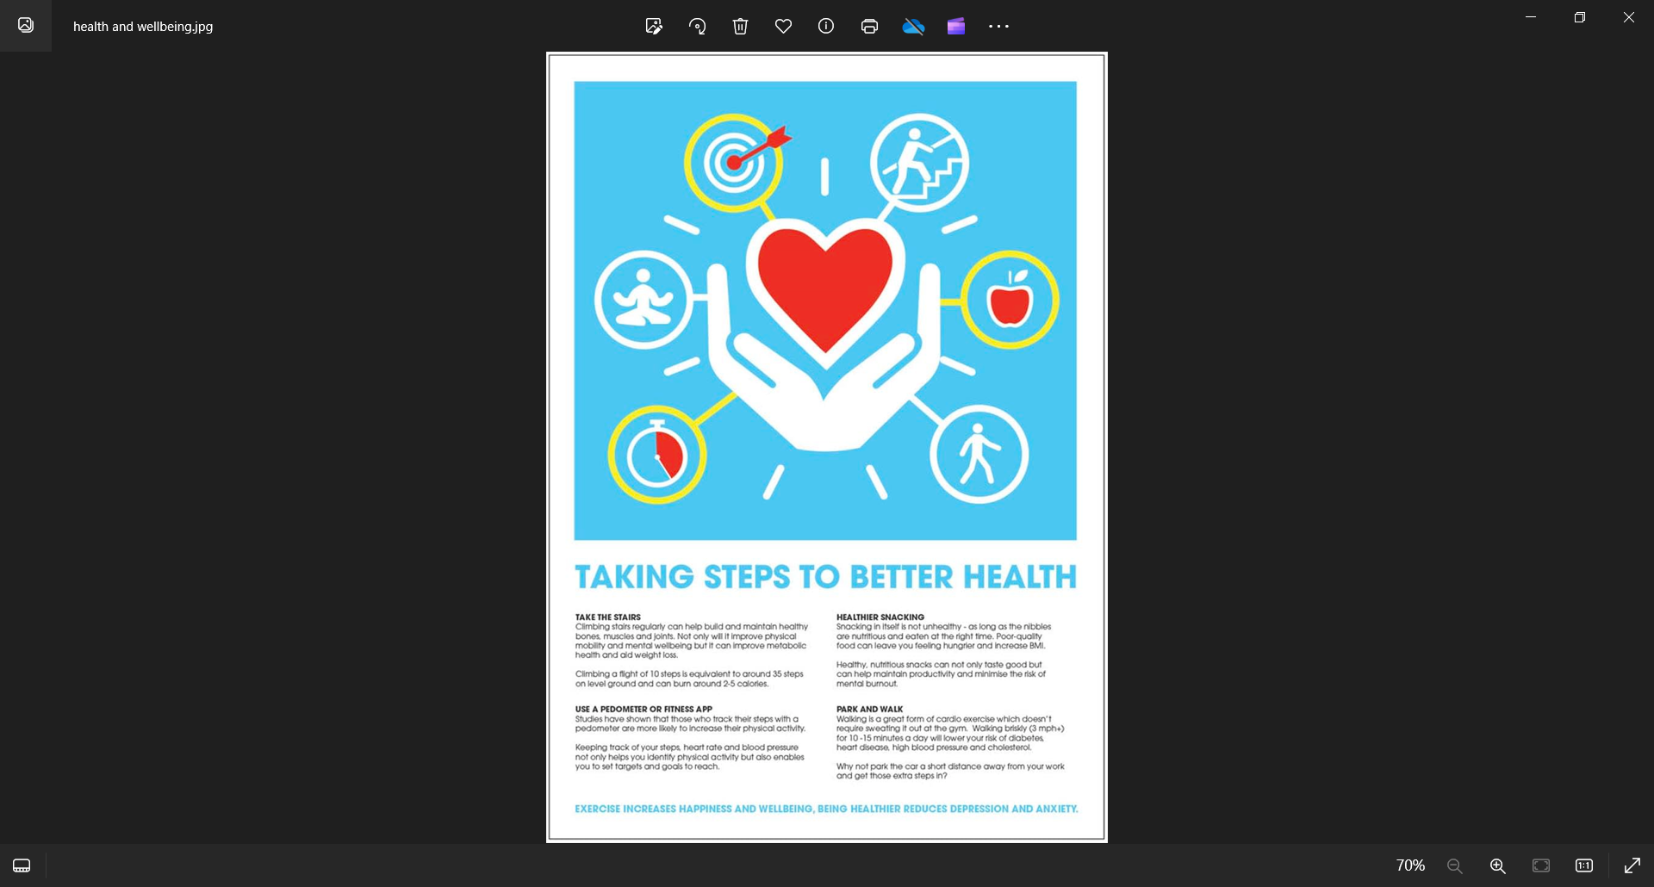
Taking steps to better health
FREE HEALTH AND WELLBEING COACHING SERVICE
What we can help with:
- Evidence based nutrition advice | - Weight management | - Coping with life changes | - Disease prevention
- Living well with long term conditions | - Returning to work after absence or unemployment | - Creating positive connections and relationships | - Self-confidence, motivation and goal setting
- How to get active | - Stress reduction | - Reducing smoking | - Sleeping well
For Appointments - your receptionist, GP or nurse can request an initial appointment or you can request one via Online Consultations on the practice website.

